**Lab – 26: How to manually change the default label and how to remove the classification completely?**

**Objective:** The objective of this lab is –

* To manually change the default label and how to remove the classification completely.

In this lab, you see how easy it is to start labeling and protecting your document, using the policy that we configured. Classification and protection happen when you save the document, but before we do that, we'll use our unsaved document to see how easy it is to apply and change labels.

**Prerequisite:** EMS Enterprise Mobility + Security E5.

**Steps:**

1. On the Information Protection bar, select the last label and you see how sub-labels display: Select one of these sub-labels, and you see how the other labels no longer display on the bar now that you've selected a label for this document.

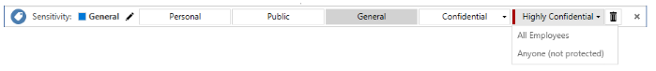

1. The **Sensitivity** value changes to show the label and sub-label name, with a corresponding change in label color.



1. On the Information Protection bar, click the **Edit Label** icon next to the currently selected label value:



1. This displays the available labels again. Now select the first label, **Personal**. Now see, the Sensitivity value changes to **Personal** and the other labels are hidden again.



1. On the Information Protection bar, click the **Edit Label** icon again. But instead of choosing one of the labels, click the **Delete Label** icon:



1. A confirmation pop-up box will open, click **Yes** to confirm that you want to delete this label.

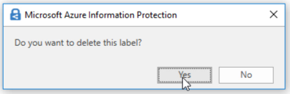

1. You see the **Sensitivity** value display **Not set**, which is what users see initially if you don't set a default label.